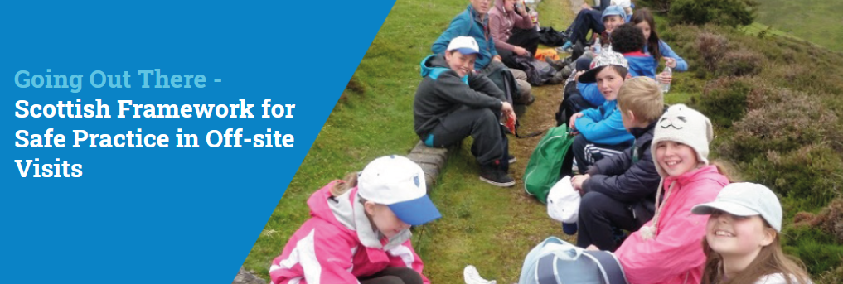

Revision of Going Out There
Launched Friday 30th October 2026
https://www.goingoutthere.co.uk/
The Scottish Advisory Panel for Outdoor Education is pleased to announce the launch of the revised guidance for Going Out There - Scottish Framework for Safe Practice in Off-site Visits.
Features of this revision include:
- An updated interactive version of the guidance in PDF format
- A print-friendly version of the guidance in PDF format
- New sections on UNCRC, GDPR and Educational Visits Coordinator and a new toolkit on Involving children and young people in planning off-site visits.

Going Out There - Scottish Framework for Safe Practice in Off-site Visits
This framework has been developed in partnership by the Scottish Government, the Health and Safety Executive (HSE), the Scottish Advisory Panel for Outdoor Education (SAPOE), Education Scotland, and the Association of Directors of Education, with input from other partners including voluntary organisations and providers.

#goingoutthere #outdoorlearning



