

Lead Officer Update JANUARY-MAY 2026
Summary of working hours to end May date 2026 |  | Hours Balance
Annual Expected Hours @ 14hrs/week | 616
To 31/5/26 = 21 weeks @ 14hrs/week | 294
Actual hours worked | 285
+/- | -9
Excess hours carried forward from 2025 | +38.75 | +23.75

Holiday in April reduced hours worked.
Time taken off in January & May for family bereavement.

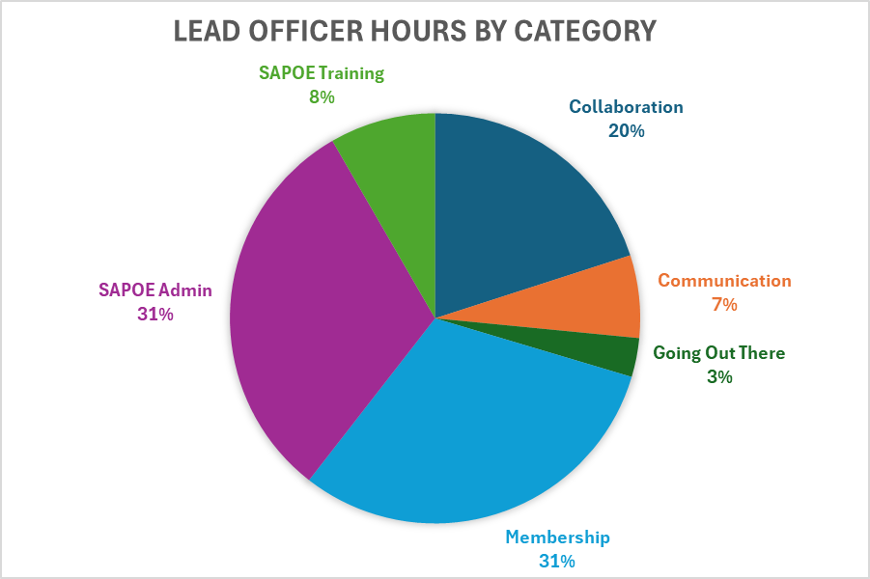

Lead Officer time on projects
Membership  31% | Collaboration & Representation  20% | Communication  7% | GOT / Training  11% | SAPOE Admin / Other  31%
Members survey 2025-26 | SOLSWG | Communications plan review work | GOT training meetings | Lead Officer updates
Annual Report 2026 | CIC Project | SAPOE Website updates | GOT website | SAPOE meeting prep
Newsletters | Due Diligence Project | SAPOE Website design | GOT project work | SAPOE AGM prep
Annual Planner | SAAF workforce group | Social Media updates – Linked In | SLO/TLO project | Exec meetings
Chair’s letter 2026 | HQ Residential Guiding Framework | SAPOE systems -  MS Office | Conference Review | Lead officer updates
Member direct contact | Partners Communications | General Email Communication |  | SAPOE general admin
Member Admin & Comms

Key Progress 2026
Area of Work | Core Strategy Action
Membership survey | 1.2
Produced a survey summary and presented key findings at the AGM. Also used the survey to inform exec decisions and also to inform aspects of the annual report.
Membership | 1.3
Number of local authorities with a named contact has increased to 30. This years ambition is to increase the number of paid up members (currently 20 in 2025-26) and improve engagement with less active members.
Newsletter & email contact using mailchimp | 1.2
Four newsletters designed and distributed to SAPOE members, partners and subscribers.
Annual Report | 6.1
The second annual report was again designed with input from Ida Maspero and Julie Young (Closer Creative). This was distributed along with the Chairs Letters to Chief Executives and Directors of Education. It was also circulated to members and partners and promoted publicly via the SAPOE website and Linked In platform.
Chair’s Letter to CE and Directors of Education | 1.3, 4.1
The letter was written again with input from Ida Maspero and had a focus on membership and improving engagement with less active LAs. It was delivered along with the annual report. An individualised letter was sent to local authorities with no named rep or where the rep has been inactive for various reasons.
SAPOE CIC Working Group | 4.1
This years CIC work has been about developing a closer working relationship with Education Scotland through an online presentation by Ollie Bray and workshop with key Education Scotland staff. This resulted in around 10 SAPOE representatives attending subject collaboration groups. Next steps are to continue the engagement Aug-Sep during the next phase of curriculum development.
SOLSWG meetings and Providing SAPOE responses | 4.1
Continued to contribute to the work of the group and also facilitated the sharing of information with the SAPOE CIC group. Coordinated SAPOE feedback to draft recommendations.
This group is currently paused until new ministers are appointed
Partners Communications | 5.2
Contact with SAAF, AHOEC, Education Scotland, ADES, Scottish Government, Nature Scot and other partners.
Website Updates and Organisation, MS365 Management | 8.1
Regular catching up with web host and MS365 support to ensure systems are operating in an efficient way to support the organisation. Started the process of some layout improvements to the website.
Residential OE Guiding Framework | 4.1
Working alongside ES and AHOEC to produce this guidance document as a template for schools and centres to ensure the residential experience is one of value, justifies costs and time and meets the needs of learners.
SAPOE continue to contribute to this group as a pilot project is planned to introduce the framework.
GOT Working Group
Active member of the GOT working group supporting with admin, basic website work and assisting with reviewing and developing new material.
Training Working Group
Active member of the SAPOE Training working group supporting with admin, basic website work and assisting with reviewing and developing new material.

Potential 2026-27 Priorities
Expand membership options (Action1.5)
Generate income/funding around training (Action 2.2)
Active recruitment of exec posts (Action 3.2)
Rewrite training outcomes Actions (6 & 7)
Further improvements to website functions (Outcome 8)
Guidance for LA on skills criteria for members (linked to Action 1.3)

