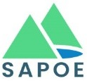
Scottish Advisory Panel for Outdoor Education
National members’ meeting minutes

Date: 3rd March 2026, 10.00 - 12.30
Venue: Glasgow City Chambers: In-person meeting

Attendees | Apologies
Tim Pickering – CnES / SAPOE Chair.  Niall Ritchie - Aberdeenshire  Andrew McNaughton - North Lanarkshire  Alan Dunlop – Fife Council  Alan Smith - East Dunbartonshire Council  Neil Baird – YouthLink Scotland  Willie White – East Ayrshire Council  John Jackson – Falkirk Council  Iain Richardson - West Lothian Leisure  Liz Brooks - East Lothian Council  Ali Dreyer (SAPOE Officer)  Viks Williams – Glasgow City Council  Dave Ogilvie - SCIS | Bill Stephen - Midlothian  Natalie White – Argyll & Bute Council  Des Bagshaw – SCIS  Andrew Bradshaw – City of Edinburgh Council  Neil Wightwick – Glasgow City Council  Frances Kelly – HSE  Nick Lansdell – Honorary Member  Ian Menzies – Education Scotland  Gordon Smith – Scottish Borders Council  Chris Jex – Orkney Islands Council  Gareth Beaton – Clackmannanshire Council  Carolyn McFarlane – Thrive Outdoors

Notes & Actions
Item | Notes | Actions
Welcome & apologies | Tim Pickering – CnES / SAPOE Chair. | N/A
Minutes and matters arising from the previous meeting. | Meeting minutes approved. No matters arising. | N/A.
Training Update | Overview of Training Modules to be produced (Draft)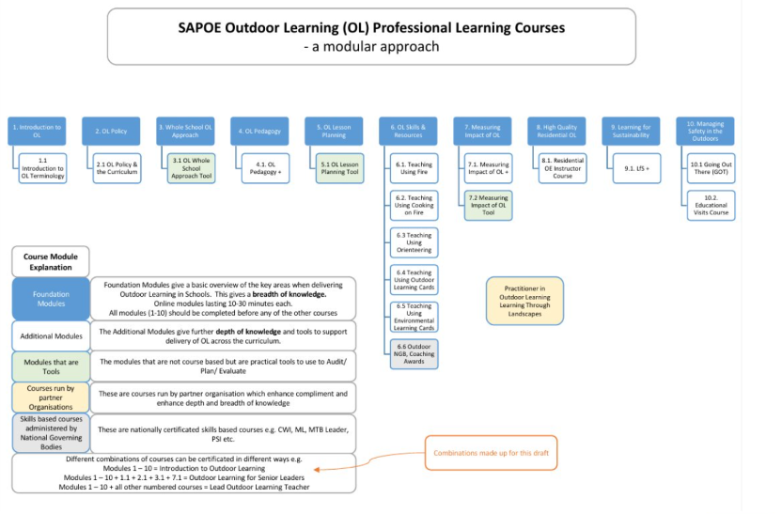 | AD – follow up further funding applications

GOT | GOT – Update 2026  - Final proof of the 2026 digital Going Out There version being completed  - Go Live date March 2026 along with an updated printable version.  - Website changing to be a landing page for digital pdf and printable versions only  - Website will also host the toolkits and appendices  - This will improve efficiency of future updates  - New section on Educational Visit’s Coordinator (EVC) role with schools and organisations  - A funding Bid for 2026 – 2027 has been submitted to Scot Gov with the main focus being on the promotion of GOT across Scotland both at grassroot level and strategic development.  - The GOT and Training teams will collaborate on relevant elements of training.  As always, we are looking for members who would like to be involved with future GOT updates.
CIC – Education Scotland | Video – will be released after the Education Scotland Meeting on 10th March.  Highlight teacher training at the meeting, links in with Professional Learning  SOLSWG – Recommendations paper going to SG ministers next week beginning 9th March. | AD – Send out CIC Video
Lead Officer update –  Ali Dreyer | Lead Officer Review – Full Document here  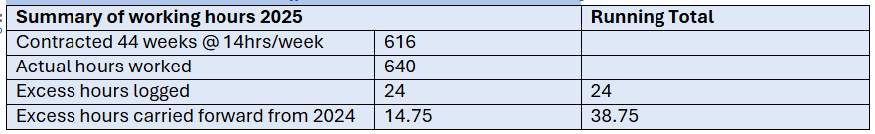  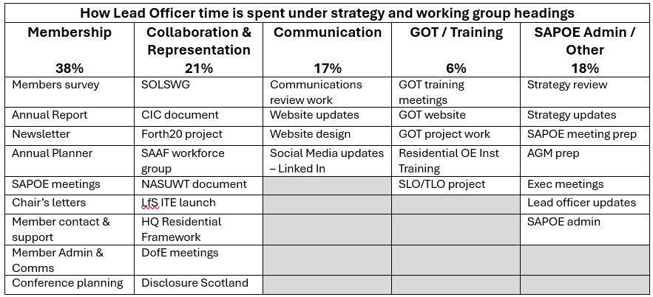  Priorities for 2026  Membership  - Expand membership options (Action 1.5)  - Proactively contact members to increase engagement across all LA’s using good practice case studies & promote benefits  - Active recruitment for Exec posts 2027 (Action 3.2)  - Develop guidance for LA’s on skills criteria for members (linked to Action 1.3)  - Generate funding/income around the training offering (Action 2.2)  Collaboration and Representation  - Continue to support the development of modular training course.  - Realign Outcome 7 with current training workstreams  Communication  - Continue improvements to website function and usage  Continue to support GOT and Training Working groups  Could be a full time job so actions need to be realistic  Increase in pay up by 4%  Flexibility in the hours worked to meet needs of SAPOE  The meeting agreed it has been a positive step for SAPOE to employ Ali in the Lead officer Post.  Discussion around the use of WhatsApp as a communication channel as some councils are not allowing employees to use WhatsApp | Exec to look into potential alternatives to WhatsApp and monitor situation with other councils
NGB Updates
First Aid | European Resuscitation Council protocol updates -  Resus Council updated guidance –  https://www.resus.org.uk/professional-library/2025-resuscitation-guidelines/first-aid-guidelines | All to circulate to LAs as appropriate.
Rafting | No NGB in UK – Using IRF protocols & British Canoeing Awarding Body have Raft Guiding Qualifications
UK Canyoning | Broadening committee membership and improving professionalism of organisation.  2 new awards ready to deliver.  https://ukcanyoning.org/courses/professional-courses/  Read statement from UKCA here.
National Access Forum | 20th Anniversary of Scottish Outdoor Access Code  Rambling Scotland carried out a big survey – concern about access jobs etc. being cut.  A working group has been set up to look at Commercial & Events Guidance.
Mountain Training | First female black Winter Mountain Leader has successfully passed assessment  Digital Certificates are on their way  LfS is now high on the agenda for MT
Adventure RMS – Tim Morton | New Update service website will be launched at the end of this week.  New applications up by 40% - 30% of those are in Scotland (all small providers or current providers adding to their adventurous activities.  Pete Hill is retiring from being an Inspector, which leaves 3 in Scotland  New course delivery is almost ready. These courses can be done online or 1 day in person event and are accredited by IOL.  - Appointed competent persons advising on matters of safety  - Providing and commissioning expert advice  Workshops have also been designed to cover the main inspection themes from the previous year.
AAOLEV (OEAP) | Chair - Ruth Hawker  Confirmed that OEAP is the working name of The Association of Advisers for Outdoor Learning and Educational Visits (AAOLEV) and no has charitable status.  - Passports  - Updated digital platform for communication between members & training  - New Trustees, now 12 trustees in place  Training - Stephen Brown  - Slides to show history of training with OEAP  - Visit Leader & EVC training course have now been redesigned. Stephen is offering to come to Scotland and share resources to align SAPOE & OEAP courses.  2022 – EVC Training Complete Re‑write  Updated Core Messages  • The core messages remain the same  • They have been developed further  • ALL NEW MATERIAL (in red on the slide)  Morning Session  • Benefits, addressing today’s world, and the role Outdoor Education (OE) can play  • Ofsted – what’s being noticed and published  • Legal – understanding some real cases (but few and far between)  • Practical elements – e.g., Licensing, LOTCQB, Atol, etc. OEAPNG  Afternoon  Completely Redesigned ………to allow EVCs to talk and develop  Exercise 1 Group interactive exercise  From Visit Planning to a EVC coaching role  Exercise 2 – dealing with issues  Input – micro topics – that they chose  Input – The Importance of Monitoring – Blink Monitoring  Exercise 3 – Where are you – Questions to them  Visit Leader Training Two Options  Established  ½ day – or 1 day with practical elements. *Erasmus  New Modular Form – launch 2026  The hand of the head….Staff update by evc – Opening door to training  Adviser Training –  Session 1 Common Theme – in school or online  Specialist modules – online  inc: visits to cities, abroad and exchanges*, coasts, camping on school site, transport options  (all short 20 – 50 min online training options)  MOVE Course – Worcs Coach crash  Now rolled out Nationally – a one off course for Senior Leaders  A one off course for school  Aim To help develop appropriate emergency plans  Designed by Worcestershire adviser Bill Taylor  Developed for national context  Outcome – incident or accident – part of school emergency procedures  (On the right side, in a diagonal textbox:)  Whole SLT or Online to Many! | LB – Someone in the training team to contact Stephen Brown
SAPOE Members Survey | 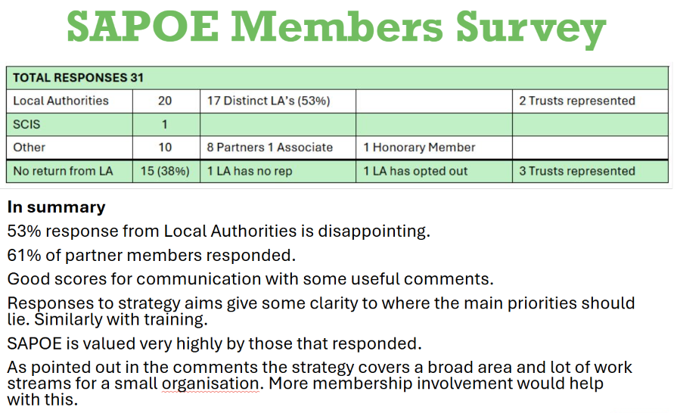  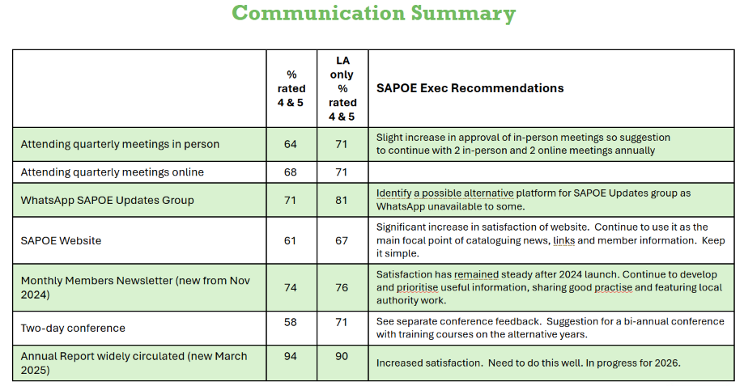  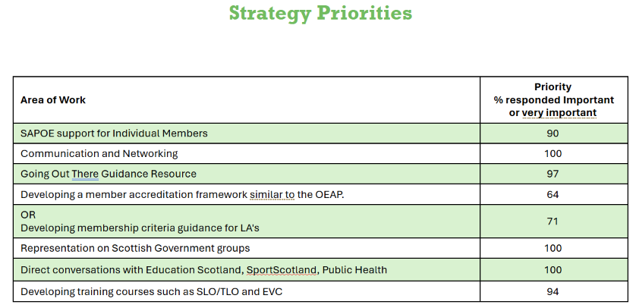  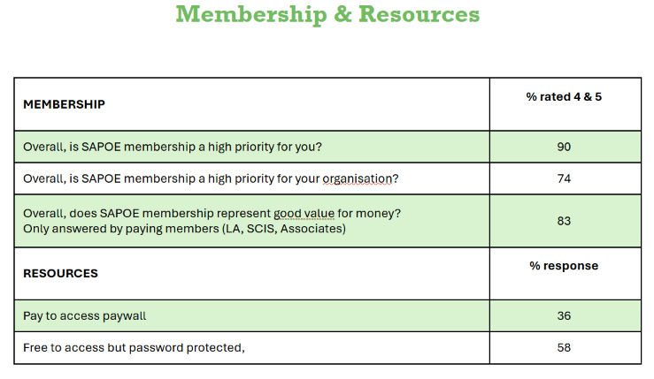  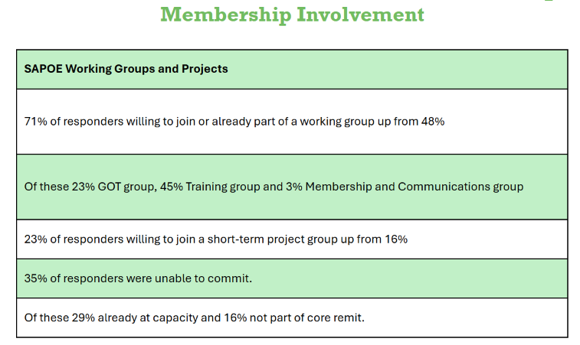
SAPOE Strategy (2024-29) | 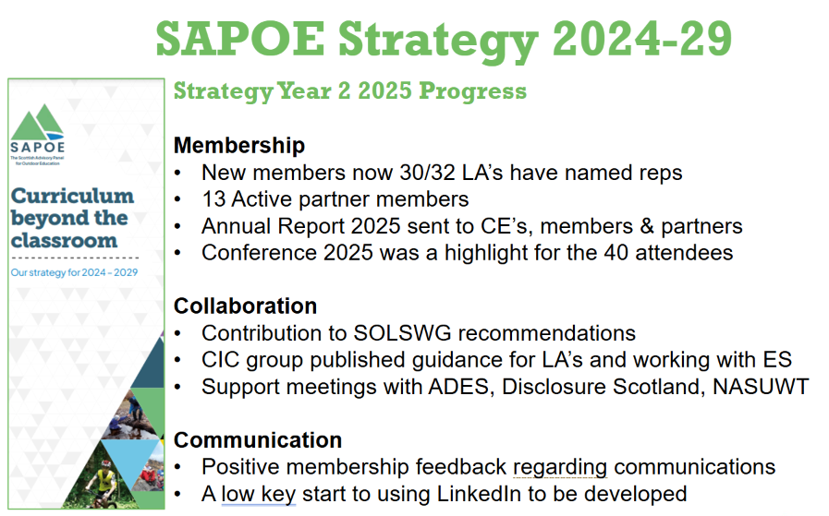  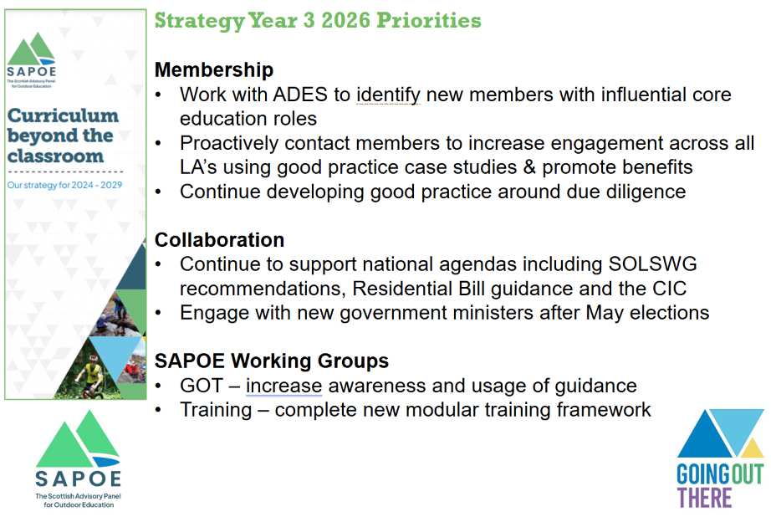 | AD – Continue working in line with the strategy
AOB | Accreditation of Outdoor Advisors – Should we have accreditation in Scotland/ SAPOE? Similar to OEAP  Risk Register for LA’s – investigate what procedures LA’s have in place? Could SAPOE hold a risk register? | AD – promote the OEAP scheme amongst SAPOE members.  Exec to consider risk register.

Notes & Actions
Completed. | N/A

[end of document]

