SAPOE TRAINING MEETING AND AGM  Loch Lomond Outdoor Centre  Wednesday 12 March 2014  9.30 for 10am | 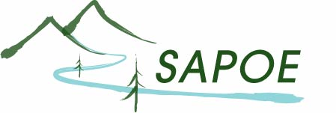  SCOTTISH ADVISORY PANEL FOR OUTDOOR EDUCATION

10.00 Welcome and Apologies

1. Snowsport Scotland Update and Future Developments – Jane Campbell-Morrison

10.30 SAPOE AGM – See separate agenda

11.30 Break

11.45 2. HSE Update from Gavin Howat

12.00 3. Education Scotland Update from Fiona Cruickshanks

12.15 4. Chair & Exec business
    - Treasurers Report & Budget – as per AGM report
    - Secretary’s Report – as per AGM report
    - Chair’s Update: NIG, SAAWG Update – Nigel Marshall
    - Going Out There Update – Jane Jackson
    - SAPOE Website Update – Natalie Polack
    - SAPOE/EVC Training – Willie White
    - Overseas Working group update & BS8848 Consultation – Elspeth Pawlak/WW
    - NGB Reps reports & questions

1.00 LUNCH & NETWORKING (Lunch available at £8 per person)

1.30 5. Presentations and Discussion around CLPL

1.30 Rosa Murray – GTCS
2.00 Fiona Cruickshanks – Education Scotland
2.20 Owen Hayward & Simon Willis – Welsh and OEAP Panels
3.00 Wrap up and actions – Chair

3.15 AOCB & Date of next meeting

  - FINISH

