SAPOE Local Authorities supporting Outdoor Learning across Scotland

ANNUAL GENERAL MEETING  At the Low Port Centre, Linlithgow  Thursday 13th September 2012, 9.30 for 10am. | 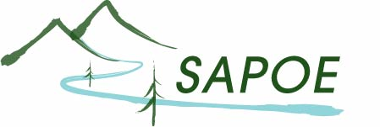
 | SCOTTISH ADVISORY PANEL FOR OUTDOOR EDUCATION

- Minutes of previous meeting

- Matters Arising

- Chairperson’s Report

- Secretary’s Report

- Treasurer’s Report

- Election of Office Bearers

 | 2011/12 | 2012/13
Chair person | N Marshall
Vice Chair | C Smith
Vice Chair | J Jackson H
Treasurer | A Beveridge
Secretary | A Dreyer

- Election of Representatives on other organisations

 | 2011/12 | 2012/13
Adventure Activities Industry Advisory Committee (AAIA) | D Horrocks | ?
Mountain Leader Training Scotland (MLTS) | N Lansdell | ?
National Access Forum (NAF) | J Kitching | ?
Real World Learning Scotland Partnership (RWL) | W White | ?
Royal Yachting Association (RYA) | J Hall | ?
Scottish Canoe Association (SCA) | D Girling | ?
Scottish Rafting Association (SRA) | D Girling | ?
Scottish Cyclists’ Union (SCU)/SMBLA | L Jones | ?
Scottish Adventure Activities Forum (observer role) | N Marshall | ?
Scottish Mountain Safety Forum | ? | ?
SnowSport Scotland | ? | ?
SkillsActive | C Rickard | ?
Cross Party Sport Group | J Hamilton | ?

- Date of Next AGM

- AOCB

