

Learning for sustainability (LfS) whole school self-evaluation tool

Learning for sustainability (LfS) is an approach to learning, life and work. It enables learners, educators, schools and their wider communities to build a socially-just, sustainable and equitable society. An effective whole school and community approach to LfS weaves together global citizenship, sustainable development education, outdoor learning and children’s rights to create coherent, rewarding and transformative learning experiences. LfS is fully embedded in the General Teaching Council for Scotland’s Professional Standards and is recognised as an entitlement for all learners.
Strategic recommendations from the Learning for Sustainability Report (2012) are as follows:
1. All learners should have an entitlement to learning for sustainability
2. In line with the new GTCS Professional Standards, every practitioner, school and education leader should demonstrate learning for sustainability in their practice
3. Every school should have a whole school approach to learning for sustainability that is robust, demonstrable, evaluated and supported by leadership at all levels
4. All school buildings, grounds and policies should support learning for sustainability
5. A strategic national approach to supporting learning for sustainability should be established

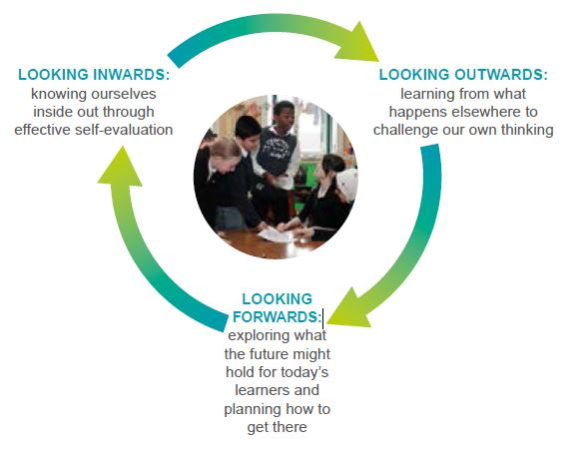
How Good Is Our School? 4 (HGIOS 4) provides a self-evaluation framework that aims to support the growth of a culture of self-improvement across Scottish education. It outlines a range of key national objectives including supporting practitioners and school leaders at all levels to “increase learning for sustainability”.

This LfS self-evaluation tool is closely aligned with HGIOS 4 and is intended to complement wider conversations around whole school evaluation. This tool aims to provide a route map for education providers to “look inwards” at the work of their establishment through the lens of LfS. By signposting potential next steps, further support, partner organisations and exemplification of what works for establishments at different stages of their journey, the LfS tool also supports the process of “looking outwards”. Finally, maintaining a focus on the best possible outcomes and impact with a flexible approach to future developments, the LfS tool encourages “looking forwards”. Partaking in the different stages of this reflective cycle provides all stakeholders with an opportunity to reflect, celebrate achievements and identify the necessary next steps towards a coherent whole school approach to learning for sustainability.

The progression statements from ‘Starting the journey’ through to ‘Consistently delivering features of highly effective practice’ have been organised for consideration under separate headings relating to the values, purposes and principles of Curriculum for Excellence. Each set of statements has a suggested group of linked Quality Indicators (QIs) from HGIOS4. Whilst this group of QIs may sit predominantly under one of the three main categories from HGIOS4 (Leadership and Management, Learning provision, Successes and Achievements), it is important to consider the overlapping nature of the different indicators. Planned improvements in one area can have multiple benefits in others, thus increasing the school’s overall capacity for improvement.
The aims of this tool are to:
- Increase awareness, knowledge and understanding of LfS.
- Promote dialogue and action towards a whole school approach to LfS, with particular emphasis on progression in learning both within and across establishments.
- Identify what works and highlight further opportunities to meet every learners’ entitlement to LfS.
- Encourage reflection around professional values, practice and professional learning on LfS.
- Stimulate creative thinking about school buildings and grounds supporting learning and teaching.
- Provide a coherent framework for partnership working in relation to LfS.
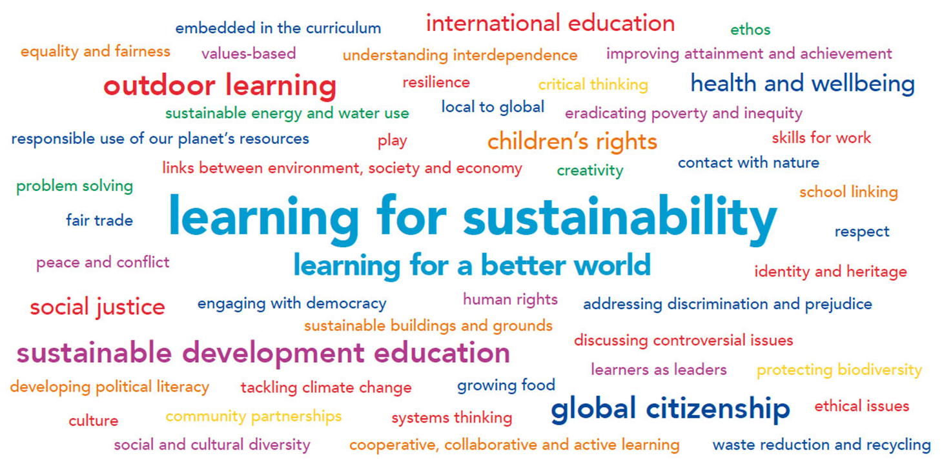

The above word cloud captures a range of LfS themes, contexts and approaches. It provides a useful reference point for staff discussion and reflection.
Sustained self-evaluation for self-improvement
 | Starting the journey  Some learners experiencing LfS, Some practitioners demonstrating LfS in their practice, School has begun to identify opportunities to connect aspects of LfS agenda. | Building on achievements  Most learners experiencing LfS and in some cases leading LfS activities , Most practitioners demonstrating LfS in their practice and beginning to lead on aspects of LfS, School has started connecting aspects of LfS agenda and is identifying further areas for coherent whole school approach. | Consistently delivering features of highly effective practice  Every learner receiving their LfS entitlement in a transformative way, Every practitioner demonstrating LfS in their practice, Whole school approach is robust, demonstrable, evaluated and supported by leadership at all levels. LfS is embedded within virtuous cycle of improvement.
Leadership and structures  HGIOS Q.I. Links  1.3, 1.4, 1.5, 2.3, 2.6 | Driving forward the LfS agenda is largely left to one or two practitioners, co-ordinators or champions. | Staff awareness and understanding of LfS is increasing. Practitioners are making positive connections between LfS and other strategic priorities. Strategic leads/ teams within and across departments/ stages are identified. Stakeholders are involved fully in development of improvement strategy that looks inwards, outwards and forwards and which sets challenging targets for improvement. Learners are at the centre of this process. | Senior management and staff continue to co-create, reflect upon and shape a shared vision and sense of purpose around LfS. Where necessary, LfS is embedded in the school improvement plan. Shared leadership regarding LfS is encouraged and supported at all levels within the community. All stakeholders, including learners can demonstrate their on-going involvement in shaping their LfS culture through planning, consultation and partnership working. The agenda has high profile and is recognised by all as being a priority and “just what we do here.”
Policies and decision making  HGIOS Q.I. Links  1.1, 1.3, 1.4, 1.5, 2.2 | Some school policies reflect LfS themes and some attempt has been made to make decision-making processes more inclusive. | A commitment has been made to increase learners’ participation in policy creation and decision making. Parents are consulted on the place of LfS within school policies and decision making processes. Staff and learners can explain which policies support LfS and how these are embedded in the life of the school. | LfS themes are central to the school vision and are reflected across school improvement plans and policies from ethical purchasing to CLPL provision for practitioners. This CLPL provision provides structured opportunities for practitioners to engage with the GTCS standards for professional registration, including those that require a commitment to “the principles of democracy and social justice through fair, transparent, inclusive and sustainable policies and practices.” The decision making process is fully inclusive and participative and involves all stakeholders. Policies and management structures are regularly reviewed to ensure they are relevant and consistent with the aims of building the skills, values and attitudes required to live sustainably and within the ecological limits of a globalised society.
Career-long professional learning (CLPL)  HGIOS Q.I. Links  1.2, 2.7 | Most staff are aware of key LfS policies and documentation.  A limited number of CLPL opportunities addressing LfS themes and approaches are provided. A few staff access these opportunities. | Most staff are engaged in a programme of career-long professional learning which supports collaborative and collegiate working. CLPL builds confidence and capacity around specific pedagogical approaches that support LfS. Professional review and development (PRD) activities include a focus on LfS. Staff increasingly engage with research on LfS and are becoming enquiring practitioners in line with the GTCS professional standards. | There is a culture of professional learning, innovation and collaborative professional enquiry in the establishment. Staff take responsibility for their own professional learning and practice draws on a wide body of research and practice from other organisations, schools and academic sources. Staff demonstrate high levels of professional commitment. In some cases this will be demonstrated through masters level learning, seeking GTCS accreditation, leadership learning through the SCEL Framework for Educational Leadership or building capacity of colleagues through mentoring approaches.  Staff think critically and share practice effectively through local, regional and national practitioner networks. Staff engage with industry, third sector organisations and further and higher education establishments to enhance LfS in their setting. Learners are supported to make the links to further study and related careers.
Ethos and life of the school, values and relationships  HGIOS Q.I. Links  1.1, 1.3, 1.4, 2.2, 3.1 | Staff understand LfS themes and can identify what this looks like in their context. LfS themes are contained within school mission and vision statements, and feature in occasional displays and assemblies. | An increased confidence in the aims and purposes of LfS is evidenced in the range of contexts for learning and the indoor and outdoor environments in which that learning takes place. The curriculum rationale has been reviewed to reflect LfS themes and approaches. Staff can be seen to “practise what they teach” in relation to LfS values and have started to share and develop their understanding of LfS with learners. All stakeholders, including parents, are finding a common language to explain how the school culture is enabling LfS. There is an increasing awareness of what children’s rights are and how they are recognised. | A positive, open and participative ethos is palpable across the school and is exemplified in a warm, respectful and caring atmosphere. This is reflected in numerous displays, community events, assemblies and, most importantly, in relationships across the school community. Learning through the ethos of the school is seen as important. Children’s rights have a high profile. Staff can confidently discuss the professional values from the relevant GTCS standards, including social justice and integrity and have reflected on how they model these values for learners. There is a significant LfS buzz throughout the school and a common sense of purpose towards building a more sustainable and equitable future for all.
Curriculum areas  and subjects  HGIOS Q.I. Links  2.2, 2.3, 2.6 ,2.7, 3.2 | LfS themes have been embedded in a few obvious curriculum areas as a result of the commitment of a small number of dedicated practitioners and/or involvement in award programmes. | Commitment to LfS builds on existing LfS provision, enabling all staff and learners to make creative connections between subject areas and other aspects of school life. Planning processes support global citizenship, sustainable development education and outdoor learning and these are increasingly seen as integrated LfS concepts. Attention has been given to progression, breadth and approaches to assessment. | LfS is used as an integrated context for learning and teaching approaches across all levels and all curriculum areas. There is clear evidence of progression, breadth and depth. Learners are motivated by relevant, challenging and enjoyable contexts for learning which develop their attitudes, values, knowledge and skills. LfS themes and approaches have a high profile and are central to transitions. The curricular offering is enhanced through the use of school buildings and grounds and community partnerships, including positive links with local businesses and employers.
Interdisciplinary learning  HGIOS Q.I. Links  2.2, 2.3, 2.6 ,3.1, 3.2 | Some attempt has been made to connect learning across a small number of subjects or curriculum areas. Learners have parallel experiences of LfS. LfS is delivered through one-off focus days/ theme weeks. | Increasingly collegiate and collaborative approaches between stage partners/ departments is resulting in stronger connections between subjects or curriculum areas. There are increased incidences of choosing real life contexts to explore connected themes or issues across curriculum areas. Good practice is emerging and being shared across the establishment. More learners display greater depth of learning. They are aware of the development of transferrable skills and can articulate attitudinal change linked to their learning experiences. | Learners have the opportunity to engage in a number of interdisciplinary activities relating to complex LfS themes which promote deep learning and the development of appropriate skills including higher-order thinking skills. Learners increasingly lead the learning and are motivated to choose relevant, real-life issues. This type of learning is enabled by responsive approaches to planning. Staff confidently include topical contexts for learning, including controversial issues, that promote participation and political literacy. Issues-based approaches are embedded in the curriculum and are delivered accordingly. Flexibility is built in to respond to unforeseen issues or to extend planned experiences beyond their original scope.
Opportunities for personal achievement  HGIOS Q.I. Links  1.2, 1.5, 2.2, 3.2, 3.3 | Staff and learners have the opportunity to engage in a number of activities such as fundraising, conservation work, campaigning and awareness raising through committees, clubs and societies. | Planning and timetabling promotes regular, structured opportunities for staff and learners to further their achievements linked to LfS. Learners are supported to make the links between their wider achievements and the development of skills for learning, life and work. Staff professional learning and partnership work with visiting specialists is geared towards increasing opportunities for wider achievement. | Learners display leadership in many areas such as community volunteering, pupil parliaments and pupil-led campaigns. These are seen to be central to the curriculum. Achievements are recognised through in-school and external accreditation programmes where appropriate. Staff accreditation and achievement is also celebrated. Learners are aware of the career opportunities linked to the broad agenda of sustainability. They choose work placements that provide an experience of the world of work related to LfS.
Making strategic connections across areas  HGIOS Q.I. Links  1.3, 2.4, 3.2, 3.3 | One or two coordinators work with learner focus groups to take forward work in relation to outdoor learning, sustainable development education and global citizenship. This activity is undertaken in relative isolation with little communication between staff. | More staff share the responsibility for working with learner focus groups. Through discussion and identification of successes and overlapping priorities, joint projects are identified and connections are made between groups. Strategic links are starting to be made between the work of learner focus groups and other planned learning experiences. Careful consideration is given to progression. | All activities are recognised as contributions towards a coherent and holistic whole school approach. Active learning experiences develop learners’ understanding of the inter-relationship of environment, society, economy and inequity, of the ecological limits to development and the interdependence of ecological and human wellbeing. Learning for sustainability is fully supported and coordinated at SMT level and there is a strategic balance across the different aspects of global citizenship, sustainable development education and outdoor learning.
Participation and learner voice  HGIOS Q.I. Links  1.1, 1.2, 1.5, 2.2 | Well established pupil councils and focus groups are in operation. Young people have the opportunity to drive forward LfS-related initiatives in a way that recognises and realises their rights. | Pupil focus groups consistently work towards worthwhile aims and are beginning to work less in isolation, spotting opportunities for collaboration and links back into the planning of their own learning. Learners display increasing confidence and political literacy.  Pupil groups look beyond the boundaries of the school to collaborate with community groups locally and other young people and organisations globally. | The importance of learner voice is recognised across the school and measures have been introduced to strengthen the learner voice across decision-making and planning and within the classroom. Learners make real decisions and have access to funds to drive their agendas forward. They are regularly consulted and get a say in what they learn and how they learn. Evaluations show learners feel valued. There is evidence that children’s rights are consistently recognised and realised throughout the establishment.
Partnerships  HGIOS Q.I. Links  1.1, 1.2, 1.5, 2.2, 2.5 | The school has long-standing partnerships with a number of local organisations and businesses and national third sector organisations including charity and voluntary groups. | The school has reinvigorated existing partnerships and forged new links, making connections between the different aspects of the LfS agenda. There is increasing evidence of how community partnerships are enhancing the curricular offering and providing more possibilities of real world learning. | Sustained effort has been made to forge a wide range of new partnerships to support learning and engage and connect young people to their communities. Partners are involved at the start of planning processes. The school is recognised as being open to new ideas and is highly regarded for the active role it plays in learning, personal development and active citizenship. Parents and community members readily lend their support to activities. Connections have been made between formal learning and community-based learning and development.
Skills and careers  HGIOS Q.I. Links  2.2, 2.4, 2.6, 2.7, 3.3 | Staff engage children and young people in meaningful discussion about their skills development and assist them in profiling to support their career journeys. | Skills, including higher order thinking skills, are developed in learners in a progressive way through careful planning and collaboration across the establishment. Learners are beginning to understand and articulate the value of the skills they are acquiring.  Links are made to employers, employability skills and awareness of associated careers. | Progression routes into careers are supported through effective partnership working. Collaborative working across the cluster ensures that skills in relation to sustainability are being developed in a coherent and progressive way. The skills being developed meet the needs of local partners, industry, further and higher education establishments and/or aspirations of learners.  Information about careers linked to the breadth of the LfS agenda and employability skills have been embedded within learning and teaching, as has the development of higher order thinking skills.
Sustainable Buildings  HGIOS Q.I. Links  1.5, 2.5, 3.3 | A whole school base-line environmental survey has been completed to identify areas for improvement.  Recycling and biodiversity monitoring is embedded in school practice. | An Environmental Management System involving relevant stakeholders is in operation and some data is being gathered to support a decreasing global footprint.  Building design systems are shared between maintenance staff (and, if relevant, construction partners) and all stakeholders. | The school has achieved reductions in the global footprint of 30%+ and has learner-led action plans in place to drive forward more progress in this area. This includes the school water footprint. The learners’ sense of ownership is palpable.  Stakeholders create opportunities to become involved with consultation and decision-making in the refurbishment /construction/ management of their environment, learning from best practice elsewhere.
School grounds  HGIOS Q.I. Links  1.1,1.2, 1.3, 1.5, 2.7 | Some effort has been made to improve school grounds to complement the indoor environment with regards to sustainability (e.g. recycling posts, composting etc.)  Some attempt has been made to optimise the use of space and to ensure that it meets a range of social learning as well as education purposes.  Staff and learners are exploring the potential for the school to be an accessible hub for engagement with the local community. | A wide variety of spaces within the campus provide a focal point for learning about local and global issues.  The outdoor environment is beginning to support daily contact with nature. The playground and other social areas support lifelong skills acquisition for communication, negotiation, cooperation, sharing, problem solving, and managing risk.  Initial steps have been taken to start planting and growing in the school grounds or in local community facilities.  The school plays an active role in the community, encouraging involvement in local decision making and including the community in decisions about the campus and its broader use and development. | The playground is a varied, stimulating learner-friendly and nature filled space, appropriate to inclusion and a diverse range of uses. Protecting and increasing biodiversity is a priority for staff and learners.  A sustained effort has been made to grow food and introduce wildlife, with clear recognition of the associated development of skills and the impact on well-being.  All stakeholders actively have ownership of and responsibility for their environment. The school is a focal point for parental and community engagement and event planning works to a sustainable procurement policy.  Staff and learners are engaged in re-creating the school as a learning centre within the community that celebrates local diversity and distinctiveness. Community organisations co-opt youth representatives from the school in order that local planning takes account of a diverse range of views and includes their contribution.
Active travel  HGIOS Q.I. Links  1.5, 3.1 | The school has a sustainable transport policy and some provision has been made for bikes and scooters but the school run remains a problem. | Access to the outdoors is available for a broad range of learning activities including regular visits to local places within walking/cycling distance of the campus. Work with a broad range of stakeholders supporting active travel is ongoing. | Bike and scooter racks are full with many others walking to school. Pupils are involved in local action planning to increase access and use of cycle routes and walkways, including street design and use of monitoring tools to improve local environmental quality. Public transport is regularly used for activities and learning visits further afield. Effective strategies are in place to decrease the number of pupils travelling to school by car.

