Proposal
To include minor adjustments on brakes as part of the trailside repairs, within the MTB Leadership Level 2 MTB Leadership course.
Proposal
After the MTB Leadership orientations were run throughout England, Scotland and Wales it was felt by the existing MBLA tutor workforce, that the award would not be ‘fit for purpose’, if the alteration of brakes were not included. After discussions at the Technical meeting of the MTB Leadership scheme, it was decided that we should set out a proposal document to show the requirements of having this included into the course.
Overview
Overarching principle – something has changed with the braking system and need to manage risk by minor adjustments to brakes to make them safe. Importantly any adjustment is for safety (risk) reasons not to improve braking performance.
Concerns with it being a high risk mechanical alteration are understandable. This document will break down how we could reduce the risk.
What is to be added to the course
Below is a list of braking systems that are being proposed to be included:
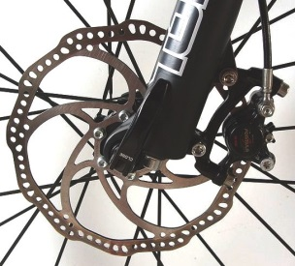
- Disc Brakes (cable and hydraulic)
Centralisation of calliper
Separation of pistons
Replacement of pads
Adjustment of the inner pad (cable disks)
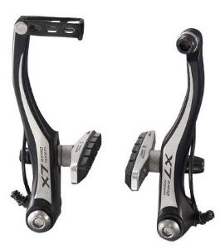
- Vbrake
Change cartridge pads
Alignment pads to rim

How to lower the level of risk
We can lower the level of risk, by having clarity that the leader is trained and assessed at the correct level to make the adjustments the brakes.
Who | How | What
The learners are trained by tutors at the correct level | Tutors to be a certified mechanic | - City and Guild cycle maintenance course  - Velotech Gold  - Cyctech Level 2
The candidates are assessed by tutors at the correct level | Tutors to be a certified mechanic | - City and Guild cycle maintenance course  - Velotech Gold  - Cyctech Level 2
Candidates to show they are competent at the required level on each criteria | Set scenarios | Tutor has to see each task on assessment

Actions
- All the Mountain Bike Leadership ‘tutors’ would have to be up-skilled to become a certified mechanic (if they are not certified already). The cost of which would have to sit with each Tutor/Provider directly.
- Tutor notes for the training would need to be written, approved and circulated
- Tutor notes for the assessment would need to be written, approved and circulated
- The timetable of delivery would need to be updated
- An addition to the handbook would be required. This could be included in the handbook in the next print run.

